 **15EC68C – PRODUCT DEVELOPMENT**

**LABORATORY**

**A Laboratory Record**

***Submitted by***

**Arafathali M (1811090)**

**Jeevananthan S K (1811036)**

**Daison Manickam A (1811401)**

***in partial fulfillment of the requirements for the award of the degree***

***of***

**BACHELOR OF ENGINEERING**

in

**ELECTRONICS AND COMMUNICATION ENGINEERING**

**NATIONAL ENGINEERING COLLEGE**

(**An Autonomous Institution Affliated To Anna University,Chennai)**

**K.R.NAGAR,KOVILPATTI – 628503**

**ANNA UNIVERSITY,CHENNAI - 600025**

**12/July/2021**

**BONAFIDE CERTIFICATE**

Certified that this report titled **“ Accident avoidance and detection system”** is the bonafide work of **“Arafathali M (1811090), Jeevananthan S K (1811036), Daison Manickam A (1811401)”** who carried out this work under my supervision.

**SIGNATURE**  **SIGNATURE**

**CONVENER**   **HEAD OF THE DEPARTMENT**

Dr.T.V IJAY ANANTH, Dr.A.SHENBAGAVALLI,

Assistant Professor(Sr.Grade) Head of the Department of ECE,

National Engineering College, National Engineering College,

K.R.Nagar ,Kovilpatti . K.R.Nagar, Kovilpatti.

Submitted for the lab examination held at NATIONAL ENGINEERING COLLEGE, K.R.Nagar, Kovilpatti on …………………

**INTERNAL EXAMINER**  **CO-EXAMINER**

**ACKNOWLEDGEMENT**

First and foremost we express our wholehearted gratitude to the Almighty for providing wisdom and courage to take over this work.

We wish to express our sincere thanks to the Director **Dr.S.Shanmugavel, B.Sc.,D.M.I.T.,Ph.D.,**who helped us in carrying our work successfully.

We would like to express our sincere thanks to our principal **Dr.K.Kalidasa Murugavel, M.E., Ph.D.,** for providing us this opportunity to do this work.

Our heartfelt acknowledgement goes to the Professor and Head of the Department, Electronics and Communication Engineering, **Dr.A.Shenbagavalli, M.E., Ph.D.,** for her valuable and consistent encouragement for carrying out the work.

Our gratitude is for our Convener **Dr. T. VIJAY ANANTH, M.E., Ph.D.,** Assistant Professor (Sr. Grade), Electronics and Communication Engineering Department for his encouragement.

We hereby acknowledge the efforts of all Staff members, Lab Technicians of Electronics and Communication Engineering Department, our Parents and our Friends whose help was instrumental in the completion of our work.

**TABLE**  **OF CONTENTS**:

*TITLE PAGE NO*

Abstract 5

Introduction 6

Main Objective 7

Components & Explanation 7

Literature Survey 11

Block diagram 13

Circuit diagram 13

Circuit Explanation 14

Flow chart 15

Working 16

Program 16

Result 24

Rating & Future Scope 26

Conclusion 26

References 27

**ABSTRACT:**

The concept of detecting car accidents is not fresh and the automobile industries have made tremendous progress in optimizing the technology. This project is an try and make a contribution in that location of generation. The Arduino Uno is an open-source microcontroller board based on the Microchip ATmega328P microcontroller and developed by Arduino.cc. The board is equipped with sets of digital and analog input/output pins that may be interfaced to various expansion boards and other circuits. then we are using Arduino uno Here we are seeking to stumble on accident through the Accelerometer as it facilitates in identifying the vicinity and if the values of x, y and z parameters are extra than the defined values than it 's going to set situation to proper and the code written for initiating the intimation and SMS alert gets executed. With this method the accident location can be detected easily and the information of the accident location can be sent via the GPS to the emergency offerings for assistance. in this accident avoidance, we are using two methods. The first one is using Ultrasonic Sensor. let's imagine the ultrasonic sensor fixed the car or any vehicle on the front body and then dc motor running clockwise direction continuously. This sensor sense the opposite car (or) any object after the DC motor running in an anticlockwise direction in five seconds only because the opposite car driver press the brake doesn't stop at the time. it goes to some distance. The second method is using a smoke sensor. When the car release the smoke (or) gas and this sensor sensed after the DC motor is stopped.

**INTRODUCTION:**

The development of a transportation system has been the generative power for human beings to have the highest civilization above creatures in the earth. Automobile has a great importance in our daily life. We utilize it to go to our work place, keep in touch with our friends and family, and deliver our goods. But it can also bring disaster to us and even can kill us through accidents. In 2020, 38,080 people died in vehicle traffic crashes only in India for Lockdown Period. Speed is one of the most important and basic risk factors in driving. It not only affects the severity of a crash, but also increases risk of being involved in a crash.

The Global Positioning System (GPS) is a popular technology which was developed by American Department of Defense (DoD) for military use. Later on it was available for civilian use. It is utilized for wide range of applications such as location, direction, speed, timing, surveying, logistics, traffic management, security etc. Nowadays, it has become an integral part of a vehicle system for tracking and navigation system. It can provide accurate time, location coordinate and speed. On the other hand, Global System for Mobile communications (GSM) is a digital mobile telephony system that is widely used. More than 690 mobile networks provide GSM services across 213 countries and GSM represents 82.4% of all global mobile connections. Besides the voice communication it also offers Short Message Service (SMS) and General packet radio service (GPRS) to transfer data. This project proposes to utilize the capability of a GPS receiver to monitor the Location and send the location and time of the accident from the GPS data processed by a Arduino Uno by using the GSM network to the Alert Service Center.

**MAIN OBJECTIVE:**

Over 75% of automobile accidents can be avoided. The main reason for that the speed of the vehicle Sometimes the car which we drive may get accident at any places, whereas we may find no source to help us out in that situation so we may get a highest probability of losing our precious lives. In that occasion we cannot search for any active sources (human) to help us out. The main objective of this project is to reduce the count of accidents and They may get minor injuries, But their lives will be saved.

**COMPONENTS:**

**Hardware Components:**

* **Arduino UNO**
* **12V , 2A Power Supply**
* **GPS Module (U-blox 6m NEO)**
* **Triple axis Accelerometer (ADXL345)**
* **Sim800 Quad Band GSM/GPRS**
* **Ultrasonic Sensor (HC-SR04)**
* **DC Motor (5V)**
* **Gas Sensor (MQ-2)**
* **Connecting Wires**
* **Breadboard**

**Software Components:**

* **Arduino IDE**

**Additional Tools:**

* **Soldering Iron**
* **Digital Multimeter (DT830D)**

**Arduino UNO:**

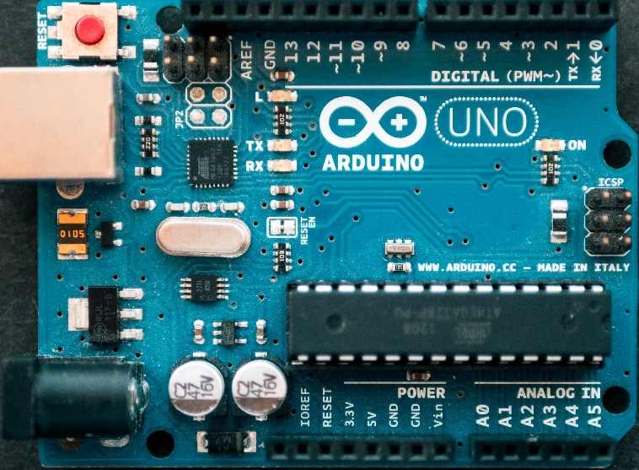

Arduino Uno is a microcontroller board based on the ATmega328P (datasheet). It has 14 digital input/output pins (of which 6 can be used as PWM outputs), 6 analog inputs, a 16 MHz ceramic resonator (CSTCE16M0V53-R0), a USB connection, a power jack, an ICSP header and a reset button. Arduino is an open-source electronics platform based on easy-to-use hardware and software. Arduino boards are able to read inputs - light on a sensor, a finger on a button, or a Twitter message - and turn it into an output - activating a motor, turning on an LED, publishing something online.

**GPS Module (U-blox 6m NEO):**

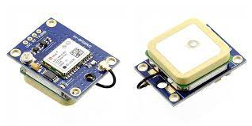

The NEO-6M GPS module is a well-performing complete GPS receiver with a built-in 25 x 25 x 4mm ceramic antenna, which provides a strong satellite search capability. With the power and signal indicators, you can monitor the status of the module. GPS receiver module gives output in standard (National Marine Electronics Association) NMEA string format. It provides output serially on Tx pin with default 9600 Baud rate. This NMEA string output from GPS receiver contains different parameters separated by commas like longitude, latitude, altitude, time etc.

**Triple axis Accelerometer (ADXL345):**

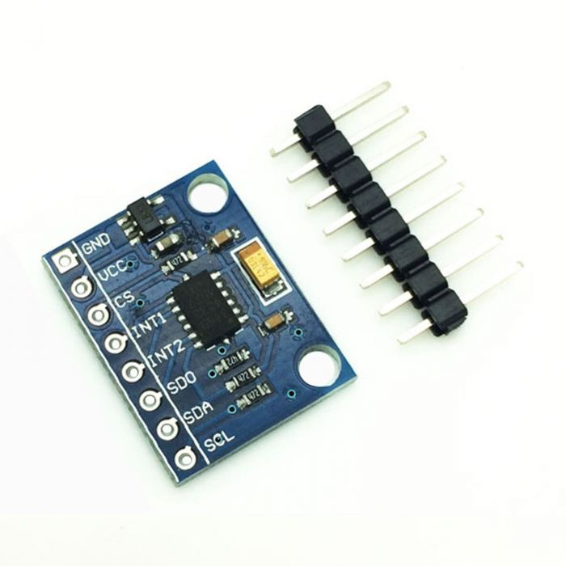

The ADXL345 is a small, thin, low power, 3-axis accelerometer with high resolution (13-bit) measurement at up to ±16g. ... It measures the static acceleration of gravity in tilt-sensing applications, as well as dynamic acceleration resulting from motion or shock. By measuring the amount of acceleration due to gravity, an accelerometer can figure out the angle it is tilted at with respect to the earth. ... The 3-Axis Accelerometer sensor will operate between 2.2 and 6 volts.

**Sim800 Quad Band GSM/GPRS:**

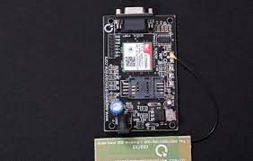

SIM800 is a quad-band GSM/GPRS module that works on frequencies 850MHz GSM, 900MHz EGSM, 1800MHz DCS, and 1900MHz PCS.It also features GPRS multi-slot class 12/class 10 (optional), and supports CS-1, CS-2, CS-3, and CS-4 GPRS coding schemes. It has one UART port.

**Ultrasonic Sensor (HC-SR04):**

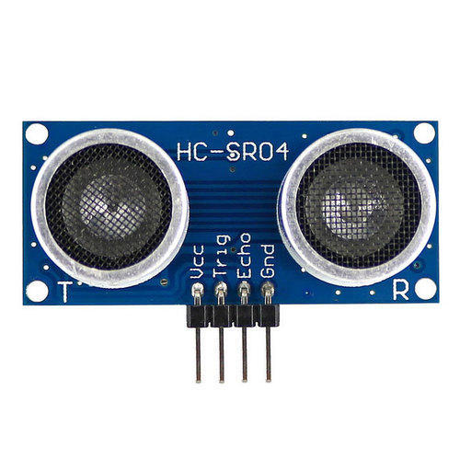

The HC-SR04 Ultrasonic Distance Sensor is a sensor used for detecting the distance to an object using sonar.The HC-SR04 uses non-contact ultrasound sonar to measure the distance to an object, and consists of two ultrasonic transmitters (basically speakers), a receiver, and a control circuit.

**Gas Sensor (MQ-2):**

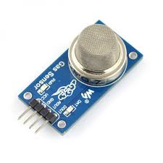

MQ2 gas sensor is an electronic sensor used for sensing the concentration of gases in the air such as LPG, propane, methane, hydrogen, alcohol, smoke and carbon monoxide. MQ2 gas sensor is also known as chemiresistor. It contains a sensing material whose resistance changes when it comes in contact with the gas**.**

**LITERATURE SURVEY:**

**Md. Syedul Amin, Jabayer Jalil (IEEE – 2017)**

Speed is one of the basic reasons for vehicle accident. Many lives could have been saved if emergency service could get accident information and reach in time. Nowadays, GPS has become an integral part of a vehicle system. This paper proposes to utilize the capability of a GPS receiver to monitor speed of a vehicle and detect accident basing on monitored speed and send accident location to an Alert Service Center. The GPS will monitor speed of a vehicle and compare with the previous speed in every second through a Microcontroller Unit. Whenever the speed will be below the specified speed, it will assume that an accident has occurred. The system will then send the accident location acquired from the GPS along with the time and the speed by utilizing the GSM network. This will help to reach the rescue service in time and save the valuable human life.

**Siva Teja, Chandra (IEEE – 2021)**

As indicated by an investigation and insights of WHO (World Health Organization), every year more than 50% of people lose their lives due to street traffic wounds of which most of them are due to bike riders as a result of head wounds. When an accident occurs, there is a delay in rescuing the person and so the proposed research work aims to work on this topic by building an automated system to alert the family member as soon as the occurrence of the accident. In this perspective, the proposed model integrates Arduino UNO R3 micro controller, a GPS GY6MV2 beneficiary and GSM module SIM 800L. Further, GPS GY6MV2 is sued to get the scope and longitude of the accident region. The GSM module SIM 800L is utilized to send SMS and enlighten the individual regarding the type of accident and provides accident location using Google Maps. ADXL335 MEMS Accelerometer sensor catches the X and Y co-ordinates of the vehicle.

**Roobam Mahajan, Mahapatra, Gaurav Khurana (IEEE – 2018)**

A blind spot detection device for protection against misshapenness such as automobiles collisions, obstacles, and accident that leads to great loss of human lives and can have disastrous results.Technology used for this purpose worked by detecting the other automobiles, obstacles and bystanders. Upon detecting, the device triggers a timer that delays the activation of alarm circuitry for a brief period of time.This time delay is instituted to minimize the triggers of nuisance alarm by a momentary intrusion in the hazard zone. If the obstaclepsilas presence is still detected after the delay time, LED's and audible alarms are triggered to alert the system operator of the dangerous situation. The alarms remain activated for a time period, allowing the operator to clear the hazard zone.

**Deepak Praveen, Raja Sree (IEEE – 2020)**

In recent years, road accidents usually occur as a result of the laxity of drivers, and the number of such accidents is increasing exponentially. Lack of care, sleep, and attention is considered as the primary factors. In this perspective, the proposed work discusses a new strategy by which an electric scooter can stop, to avoid a fatal accident. Here, a microcontroller-based braking methodology is employed. With the use of ultrasonic sensors, it appropriately detects the fast approaching obstacles in front of the scooter. Continually, the received signals are used by the microcontroller to proceed the further braking action. Also, the system has been made by considering the vehicles driven by a disabled person so that the driver can avoid the panic situation while the emergency braking is on demand.

**BLOCK DIAGRAM:**

**CIRCUIT DIAGRAM:**

**Accident Detection:**

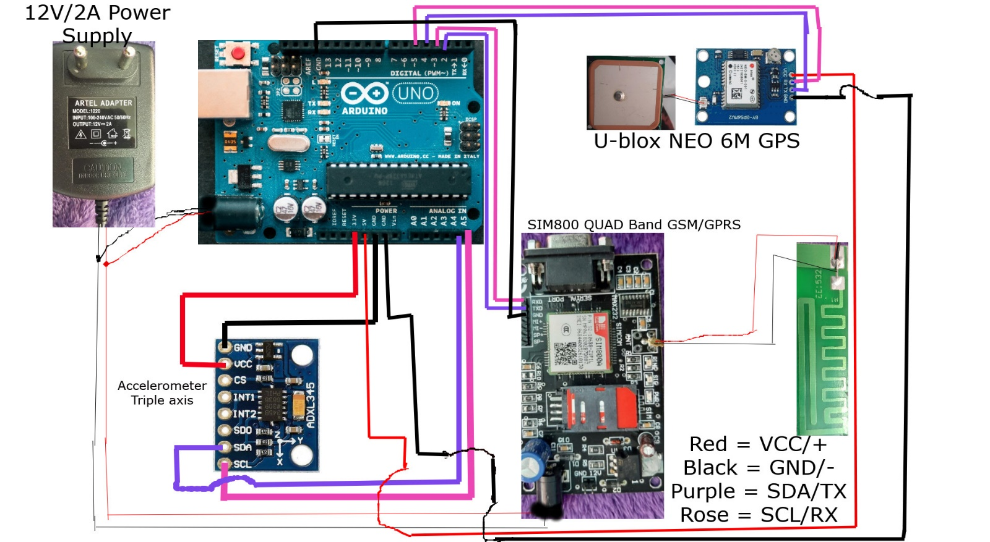

**Accident Avoidance:**

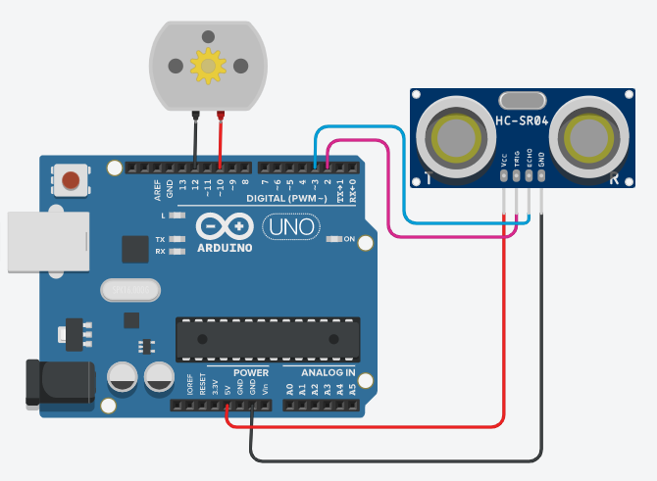

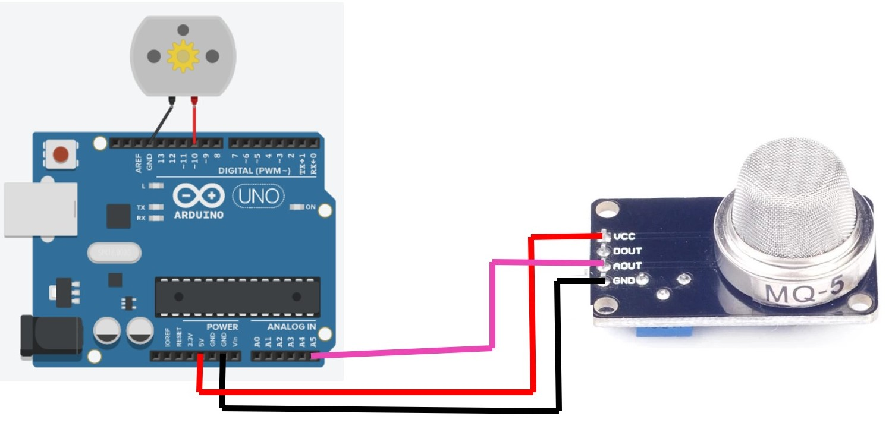

**CIRCUIT EXPLANATION:**

GSM module’s Tx and Rx pins of are directly connected to pin 2 and 3 of Arduino. For GSM interfacing, here we have also used software serial library. GSM module is also powered by 12v supply.

Circuit Connections of this Vehicle Accident Avoidance and detection System Project is simple. Here Tx pin of GPS module is directly connected to digital pin number 4 of Arduino. By using Software Serial Library here, we have allowed serial communication on pin 4 and 5, and made them Tx and Rx respectively .5 Volt supply is used to power the GPS Module.

An Accelerometer is added in this system for detecting an accident and its x,y, and z-axis output pins are directly connected to Arduino ADC pin A4 and A5.

An Ultrasonic Trigger and Echo pins of are connected to pin 2 and 3 of Arduino.

Smoke sensor AOUT Pin is connected to the A5 analog in of Arduino

If i connected ultrasonic sensor only, the motor pin + and – Pins connected to the 10 and 12 of Arduino. Then if I connected smoke sensor only, the motor pin + and – Pins connected to the 10 and GND of Arduino .

**FLOW CHART:**

In accident detection we are used function of gps.location.isValid it is used to detect the valid latitude and longtitude value. two condition are true it is send the alert sms. otherwise it doesn’t send any sms. the first condition is true its going to accelerometer axis if condition. the accelerometer do any movement then the second condition is true after send the alert sms. In the accident avoidance, distance is less than 400cm then the if condition is true after the dc motor running anti-clockwise direction. otherwise it is continuously running clockwise direction only. The smoke sensor reading value are greater than 300 then the DC motor Stopped. otherwise the DC motor running Continuously.

**WORKING:**

In this project, Arduino is used for controlling whole the process. GPS Receiver is used for detecting coordinates of the vehicle, GSM module is used for sending the alert SMS with the coordinates and the link to Google Map. Accelerometer namely ADXL335 is used for detecting accident or sudden change in any axis. Ultrasonic sensor sense the opposite any vehicle or objects then the DC motor turn Anticlockwise direction in 4 seconds only. Smoke sensor sense the smoke then the DC motor is stopped.

**CODE FOR ACCIDENT DETECTION:**

#include <Wire.h>

#include <Adafruit_Sensor.h>

#include <Adafruit_ADXL345_U.h>

#include <TinyGPS++.h>

#include <SoftwareSerial.h>

Adafruit_ADXL345_Unified accel = Adafruit_ADXL345_Unified();

TinyGPSPlus gps;

SoftwareSerial ss(4, 5);

SoftwareSerial gsm(2,3);

void setup(void)

{

Serial.begin(9600);

ss.begin(9600);

if(!accel.begin())

{

while(1);

}

}

void loop(void)

{

{while (ss.available() > 0)

if (gps.encode(ss.read()))

displayInfo();

if (millis() > 5000 && gps.charsProcessed() < 10)

{

Serial.println(F("No GPS detected: check wiring."));

while(true);

} }

if (gps.location.isValid())

{

sensors_event_t event;

accel.getEvent(&event);

if(event.acceleration.x < -2 || event.acceleration.x > 0 ||

event.acceleration.y < -3 || event.acceleration.y > 0 || event.acceleration.z < 9)

{

Serial.begin(9600);

gsm.begin(9600);

gsm.println("AT+CMGF=1");

delay(1000);

gsm.println("AT+CMGS=\"+919486701501\"\r"); //replace x by your number

delay(1000);

gsm.println("Accident Alert...");

gsm.println(" ");

gsm.println("The person met with an accident");

gsm.println("Save as soon as possible");

gsm.println(" ");

gsm.println("UTC Date => ");

gsm.print(gps.date.month());

gsm.print("/");

gsm.print(gps.date.day());

gsm.print("/");

gsm.print(gps.date.year());

gsm.println(" ");

gsm.println("UTC Time => ");

gsm.print(gps.time.hour());

gsm.print(":");

gsm.print(gps.time.minute());

gsm.print(":");

gsm.print(gps.time.second());

gsm.println(" ");

gsm.println("https://maps.google.com/maps?&z=15&mrt=yp&t=k&q=");

gsm.print(gps.location.lat(),6);

gsm.print("+");

gsm.print(gps.location.lng(),6);

delay(200);

gsm.println((char)26);

delay(1000);

exit(0);

}

}

}

void displayInfo()

{

sensors_event_t event;

accel.getEvent(&event);

Serial.print("X: "); Serial.print(event.acceleration.x); Serial.print(" ");

Serial.print("Y: "); Serial.print(event.acceleration.y); Serial.print(" ");

Serial.print("Z: "); Serial.print(event.acceleration.z); Serial.print(" ");Serial.println("m/s^2 ");

delay(500);

Serial.print(F("Location: "));

if (gps.location.isValid())

{

Serial.print(gps.location.lat(), 6);

Serial.print(F(","));

Serial.print(gps.location.lng(), 6);

}

else

{

Serial.print(F("INVALID"));

}

Serial.print(F(" Date=>"));

if (gps.date.isValid())

{

Serial.print(gps.date.month());

Serial.print(F("/"));

Serial.print(gps.date.day());

Serial.print(F("/"));

Serial.print(gps.date.year());

Serial.print(" Time=>");

Serial.print(gps.time.hour());

Serial.print(":");

Serial.print(gps.time.minute());

Serial.print(":");

Serial.print(gps.time.second());

}

else

{

Serial.print(F("INVALID"));

}

Serial.println();

}

**CODE FOR ACCIDENT AVOIDANCE:**

**Using Ultrasonic Sensor:**

#define trigPin 2

#define echoPin 3

#define motor 10

#define motor2 12

void setup(){

Serial.begin (9600);

pinMode(trigPin, OUTPUT);

pinMode(echoPin, INPUT);

pinMode(motor, OUTPUT);

pinMode(motor2, OUTPUT);

}

void loop(){

long duration, distance;

digitalWrite(trigPin, LOW);

delayMicroseconds(2);

digitalWrite(trigPin, HIGH);

delayMicroseconds(10);

digitalWrite(trigPin, LOW);

duration = pulseIn(echoPin, HIGH);

distance = (duration/2) / 29.1;

if (distance < 10){

digitalWrite(motor,LOW);

digitalWrite(motor2,HIGH);

delay(4000);

digitalWrite(motor,LOW);

digitalWrite(motor2,LOW);

exit(0);

}

else {

digitalWrite(motor,HIGH);

digitalWrite(motor2,LOW);

}

Serial.print(distance);

Serial.println(" cm");

delay(500);

}

**Using Smoke Sensor:**

int motor = 10;

int smokeA0 = A5;

int sensorThres = 300;

void setup() {

pinMode(motor, OUTPUT);

pinMode(smokeA0, INPUT);

Serial.begin(9600);

}

void loop() {

int analogSensor = analogRead(smokeA0);

Serial.print("Pin A0: ");

Serial.println(analogSensor);

if (analogSensor > sensorThres)

{

digitalWrite(motor, LOW);

exit(0);

}

else

{

digitalWrite(motor, HIGH);

}}

**RESULT:**

**For Accident Detection:**

**For Accident Avoidance:**

**RATE THIS PROJECT OF CUSTOMER:**

**FUTURE SCOPE:**

The proposed system deals with the detection of the accidents. But this can be extended by providing medication to the victims at the accident spot. By increasing the technology we can also avoid accidents by providing alerts systems that can stop the vehicle to overcome the accidents. So definitely we are develop in this project in future.

**CONCLUSION:**

The proposed system deals with the accident avoidance and detection. Arduino is the heart of the system which helps in transferring the message to different devices in the system. Accelerometer sensor will be activated when the accident occurs and the information is transferred to the registered number through GSM module. Using GPS the location can be sent through tracking system to cover the geographical coordinates over the area. The accident can be detected by an accelerometer sensor. In this accident avoidance methods is mostly save the human life, at least causing physical damage not causing damage of Life.

**REFERENCES:**

* C. Thompson, J. White, B. Dougherty, A. Albright, and D. C. Schmidt, "Using Smart phones to Detect Car Accidents and Provide Situational Awareness to Emergency Responders," in 3rd International ICST Conference on MOBILE Wireless MiddleWARE, Operating Systems, and Applications (Mobilware 2018), 2018.
* “Vehicle Accident Detection And Reporting System Using Gps And Gsm.” by AboliRavindraWakure, ApurvaRajendraPatkar, IJERGS April 2014.
* D. A. Whitney and J. J. Pisano TASC, Inc., Reading, Massachusetts, "Auto Alert: Automated Acoustic Detection of Incidents", IDEA project, [Online]. Accessed on 15 October 2011, Available: <http://pubsindex.trb.org/view.aspx?id=481489>
* Ollis, M.HERMAN.H. & SINGH.S, “Analysis and design panaromic stereo vision using equi-angular pixel cameras”, technical report, Carnegie Mellon Robotics university, 1999.
* Sogo,t.& Ishiguro,h.(2000), “Real-time target localization and tracking by n-ocular stereo”, in IEEE, pp.45-53.

**YOUTUBE LINKS IN MY PROJECT:**

* <https://youtu.be/7zF_SymW2OM> (Accident Detection)
* <https://youtu.be/t18B1AMP1U8> (Accident Avoidance)